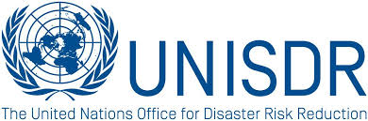
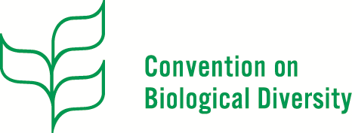
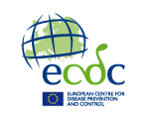

Statement submitted on behalf of EcoHealth Alliance, UNISDR, UN Biodiversity Convention, ECDC and several health partners

Health disasters from biological hazards threaten lives and economies. The devastating Ebola crisis in West Africa caused over 11,000 deaths and widespread socio-economic impact, with combined 12% GDP loss for Guinea, Liberia and Sierra Leone. The World Bank estimates a severe Influenza pandemic may cost US$3 trillion globally - but this amount could be greatly reduced with strong preparedness.
The prevailing approach to health emergencies and disasters is highly reactive, missing critical opportunities for prevention, early warning and detection, and timely effective response. Consequences include preventable loss of life and productivity, frequently with wide-ranging financial impacts on several sectors.
The 2016 Bangkok Principles for the implementation of health aspects of the Sendai Framework offer key actions to be taken by countries and agencies to optimize prevention, preparedness, response and recovery from health emergencies and tackle health impacts of other disasters. These require whole-of-society participation to integrate risk-informed planning into the health sector and promote health system resilience. The Bangkok principles include the following:
1) Promote systematic integration of health into national and sub-national disaster risk reduction policies and plans and the inclusion of emergency and disaster risk management programs in national and sub-national health strategies
2) Enhance cooperation between health authorities and other relevant stakeholders to strengthen country capacity for disaster risk management for health, the implementation of the International Health Regulations (2005) and building of resilient health systems.
3) Stimulate people-centered public and private investment in emergency and disaster risk reduction, including in health facilities and infrastructure.
4) Integrate disaster risk reduction into health education and training and strengthen capacity building of health workers in disaster risk reduction.
5) Incorporate disaster-related mortality, morbidity and disability data into multi-hazards early warning system, health core indicators and national risk assessments

6) Advocate for, and support cross-sectoral, transboundary collaboration including information sharing, and science and technology for all hazards, including biological hazards.

7) Promote coherence and further development of local and national policies and strategies, legal frameworks, regulations, and institutional arrangements.
We urge countries and agencies to integrate the Bangkok Principles in their DRR national and local plans toward achievement of Sendai Framework Target (E) by 2020 and related global commitments. Lessons can be learned from past experiences, such as HIV/AIDS, Ebola, Pandemic Influenza, and Zika, to build back better and reduce risk and impact of future health disasters.
Ongoing work includes the project in Ebola affected countries in West Africa implemented jointly by WHO, UNDP and UNISDR to integrate health into DRR national platforms, plans and integrate health data into disaster loss databases and risk profiling.
More and more countries are taken this agenda forward. For example, Pakistan is developing a comprehensive action plan for national and provincial-level implementation of the Bangkok Principles targeting local health workers, facilities, school health programs, Emergency Response Centers, and appointment of DRR experts in the health directorate.
The human-animal-ecosystem interface is particularly relevant when considering drivers of infectious disease emergence and spread, including changes in landuse, food production practices, climate, human settlements, and trade and travel- many which also contribute to biodiversity loss, ecosystem degradation, and extreme events. The One Health approach helps target disease threats at their source.

Scientific and technological innovation provides knowledge and tools for disease forecasting, detection, and monitoring. For example, USAID’s Emerging Pandemic Threats PREDICT project works with 30 countries to conduct pathogen surveillance in wildlife and characterize high-risk interfaces. Climate-smart healthcare initiatives promote reliable and resilient health systems in both peacetime and emergencies.

In addition to the impacts of disasters on human mortality, morbidity and disability, biohazards warrant inclusive action under the Sendai Framework. Plans should ensure integration of vulnerable populations, such as migrants, refugees, women, children, people with disabilities and the elderly; community empowerment; adaptive governance and management; and improved ecosystem management and ecosystem-based approaches to DRR.

Health system capacities, multisectoral collaboration and inclusive risk management reinforce the SDGs, Paris Agreement, New Urban Agenda, biodiversity and health initiatives, ecosystem-based approaches to climate adaptation and disaster risk reduction, and those related to health emergencies and risk management such as the International Health Regulations and Global Health Security Agenda.

We commit to communicate these key messages to our governments, institutions and communities to reduce the threat of health disasters.

